**STD Document**

**Ali Drawy**

**Table of Contents**

Introduction2

Document Overview2

Abbreviations 2

Glossary 2

Test Preparations 4

Tests Descriptions6

1. **Introduction**

This document serves as the Software Test Description (STD) for the YouTube software development project. It outlines the comprehensive testing procedures for both functional and non-functional aspects of the YouTube platform. The tests described herein aim to ensure the reliability, functionality, security, and performance of YouTube, thereby providing users with a seamless and satisfying experience.

**Document Overview:**

This document serves as the software test description for the YouTube software development project. It provides a comprehensive overview of the tests outlined in the software test plan. These tests are important to the success of the project as they include both functional and non-functional aspects, ensuring the platform's stability and reliability.

The test types covered in this description include:

**Functional Tests:** These encompass various aspects such as integration, unit testing, sanity checks, and user interface (UI) testing to validate the functionality of the YouTube platform.

**Non-Functional Tests:** These tests focus on critical aspects beyond functionality, including performance evaluation, security measures, and globalization testing. They are essential for guaranteeing that YouTube meets the highest standards of performance, security, and accessibility across diverse user demographics and regions.

**Abbreviations:**

* **STD: Software Test Description**
* **GUI: Graphical User Interface**
* **OS: Operating System**
* **API: Application Programming Interface**
* **QA: Quality Assurance**
* **UI: User Interface**

**Glossary:**

* **Test Case:** A specific set of conditions and actions designed to verify the functionality, behavior, or performance of a software application.
* **Traceability:** The ability to track and link project artifacts, such as requirements, design elements, and test cases, throughout the software development lifecycle to ensure alignment and completeness.
* **Integration Testing:** Testing approach that verifies the interactions between different software modules or components to ensure they function together correctly.
* **Unit Testing:** Testing methodology where individual units or components of a software application are tested in isolation to validate their functionality.
* **Sanity Testing:** Subset of regression testing focused on quickly determining whether recent changes to the software have not adversely affected its existing functionalities.
* **Performance Testing:** Testing technique used to assess the speed, responsiveness, scalability, and stability of a software application under various workload conditions.
* **Security Testing:** Testing process that evaluates the software's ability to protect data, maintain functionality, and resist unauthorized access.
* **Globalization Testing:** Testing approach aimed at ensuring that a software application can function properly across different languages, cultures, and regions.
* **Functional Requirements:** Specifications detailing the desired behavior and functionalities of a software application.
* **Non-Functional Requirements**: Specifications concerning aspects such as performance, security, usability, and reliability, which are not directly related to the application's functionality but are crucial for its overall success.
* **User Acceptance Testing** (UAT): Testing performed by end-users or stakeholders to validate whether the software meets their requirements and expectations before deployment.
* **Cross-Browser Testing:** Testing process that evaluates the compatibility of a web application across different web browsers to ensure consistent user experience.
* **Regression Testing:** Testing methodology focused on verifying that recent code changes have not adversely affected the existing functionalities of the software.
* **API Testing:** Testing approach that assesses the functionality, reliability, performance, and security of application programming interfaces.
* **Load Testing:** Testing methodology focused on evaluating the behavior of a software application under anticipated and peak workload conditions.
* **Usability Testing**: Testing process that assesses how easy and intuitive it is for users to interact with a software application to accomplish their tasks effectively.

**2. Test Preparations for YouTube**

**2.1** The sub-sections to be tested:

This test preparation plan is designed to cover various aspects of testing on YouTube:

* Hardware Preparation.
* Software Preparation.
* Localization Settings.
* Safety, security and privacy precautions.
* Usability Testing
* Performance Testing
  + 1. **Hardware Preparation:**

Ensure a mix of desktop and mobile devices for comprehensive testing across different platforms and screen sizes. Test on various network conditions to evaluate performance under different scenarios.

**Device Selection**

* Laptop Devices:
* Windows laptop: a Windows laptop for testing purposes
* Mobile Devices:
* Samsung Galaxy S21 (Android 11): Samsung Galaxy S20 running Android 11 for Android testing.

**Network Conditions**

* Test on various network speeds (3G, 4G, Wi-Fi).
* Evaluate performance under low bandwidth conditions.

The initial phase of device selection involves identifying a diverse set of devices for YouTube testing, including laptops, and mobile devices. The selected devices represent a variety of configurations, covering different operating systems, screen sizes, and browser or app configurations. This comprehensive approach ensures thorough testing across various platforms and enhances the overall quality of the testing process.

**2.1.2 Software Preparation:**

Install and configure different operating systems and browsers to validate YouTube compatibility. Adjust language and regional settings for testing localization features.

**2.1.3 Localization Settings:**

* Adjust language and regional settings for testing localization features.
* Validate the application's response to different language and regional configurations.

The Localization Settings phase is dedicated to testing YouTube’s adaptability to different languages and regional configurations. By adjusting language and regional settings, the testing team aims to validate the application's responsiveness to diverse linguistic and cultural requirements.

**2.1.4 Safety, security and privacy precautions.**

* User Privacy Protection:
* Ensure that test accounts don't contain personal or sensitive information.
* Test and verify privacy settings for user accounts.
* Security Measures:
* Confirm that testing procedures adhere to security protocols.
* Use dummy data for security-sensitive tests.

The Safety, Security, and Privacy Precautions phase is designed to safeguard user data and uphold the integrity of the testing process. By implementing privacy protection measures and adhering to security protocols, this phase ensures responsible testing practices.

**2.1.5 Usability Testing**

* Navigation and Layout:
* Evaluate the intuitiveness of navigation and overall layout.
* Confirm a seamless user experience on various mobile devices.

The Usability Testing phase focuses on optimizing the user experience by evaluating navigation, mobile responsiveness, accessibility features, and multilingual support. By conducting comprehensive usability tests, YouTube aims to provide an intuitive and accessible platform for users worldwide.

* + 1. **Tests Descriptions**

Comprehensive testing is paramount to ensure the reliability, functionality and security of applications. Test case descriptions serve as a basis for systematic and organized testing procedures, and provide a road map for evaluating the performance of various software features.

Each test case description describes the steps, conditions, and expected results of specific tests, which not only makes it easier to identify potential problems but also contributes to clarity and overall understanding of the testing process.

**There are some examples here**

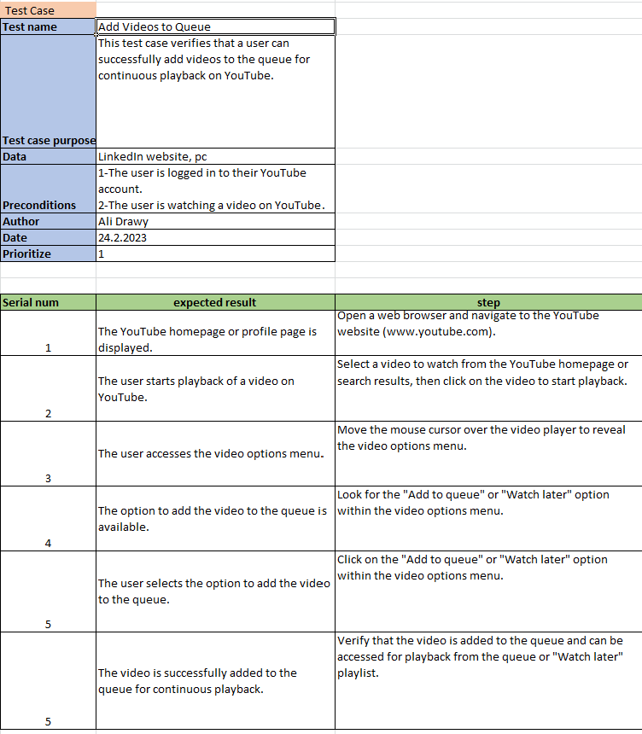

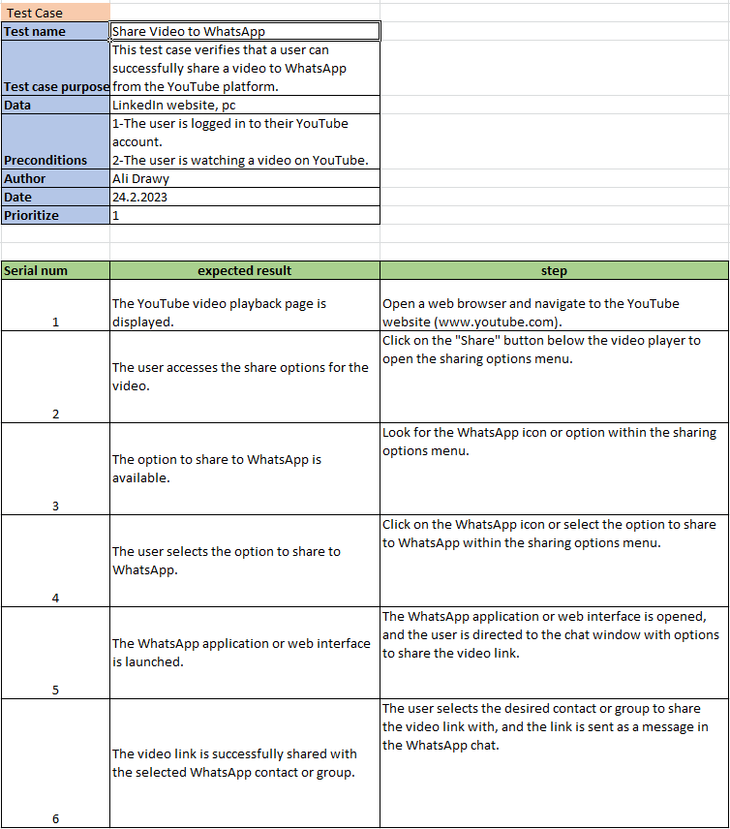

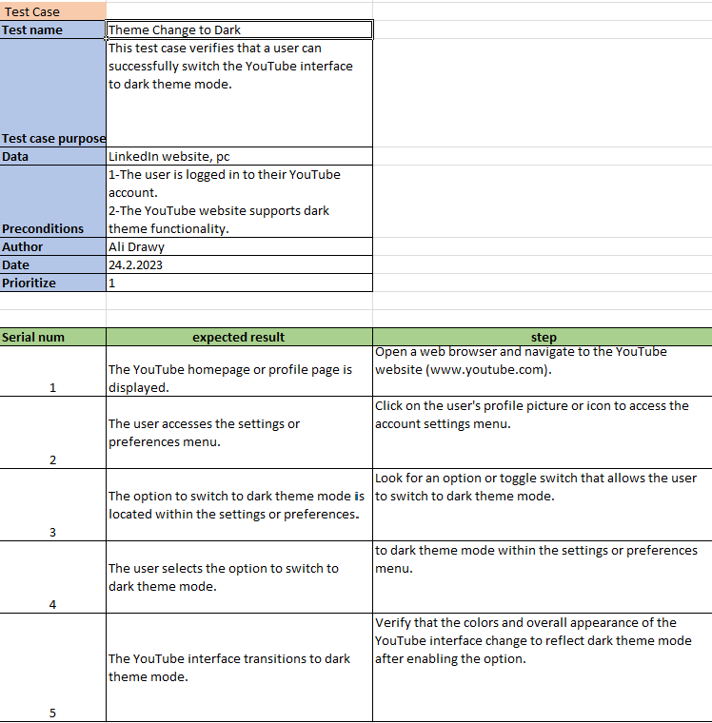

* + 1. **Conclusion**

The Software Testing Document (STD) outlines a robust testing framework for YouTube, encompassing various functional and non-functional aspects. Through systematic testing procedures, YouTube endeavors to guarantee the reliability, functionality, security, and performance of its platform. By conducting comprehensive testing across different functionalities, YouTube is committed to delivering a seamless and enjoyable user experience to its audience.